**MultiMedia and ARIA in HTML**

* In this section, we are going to learn about semantics(left-over stuff), multimedia and ARIA labels.

1. Figure tag <figure></figure> is another way of adding images to webpages.

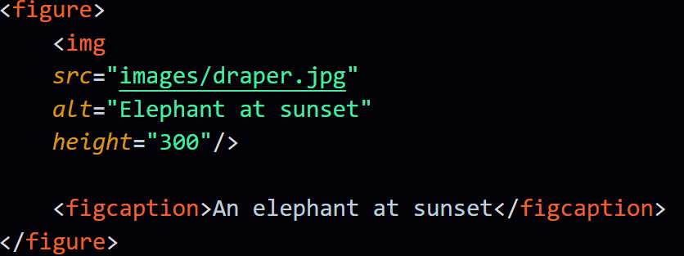

1. ARIA stands for Accessible Rich Internet Applications.

Output:  
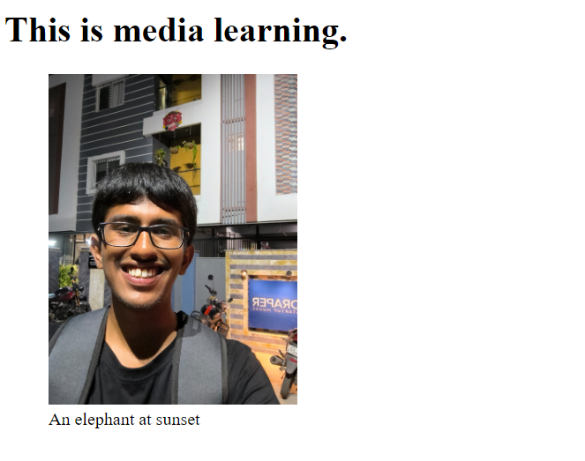



1. Video + tab => <video></video>
2. controls in video tag, fires up the video’s life, without controls the video won’t play or run.
3. controlslist attribute in video tag is used to control the features that we allow for the users to use.
4. Before “nodownload” applied in the video tag,   
   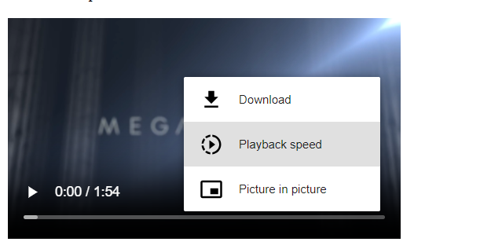
5. After “nodownload” applied in the video tag,  
   